**WEB APPLICATION FOR A FLEET MANAGEMENT SYSTEM**

**ADEDOLAPO ADETONA**

**B00855779**

Contents

Introduction 3

Functional Requirements 3

Models 4

View screenshots and codes 7

# Introduction

This is a fleet web application for the management of Vehicles and their corresponding MOT(s).

The design of this web application involves access of different users (Guest, Manager and Administrator) to different functionalities to the web data ranging from view/read only to edit functions.

# Functional Requirements

The application is to be built to enable:

1) The inputting of Vehicles and their corresponding MOTs.

2) System ability to create, delete, view and edit Vehicle

3) System ability to create, delete and view each MOT tied to a Vehicle without affecting the Vehicle

# Models

Vehicle Model:

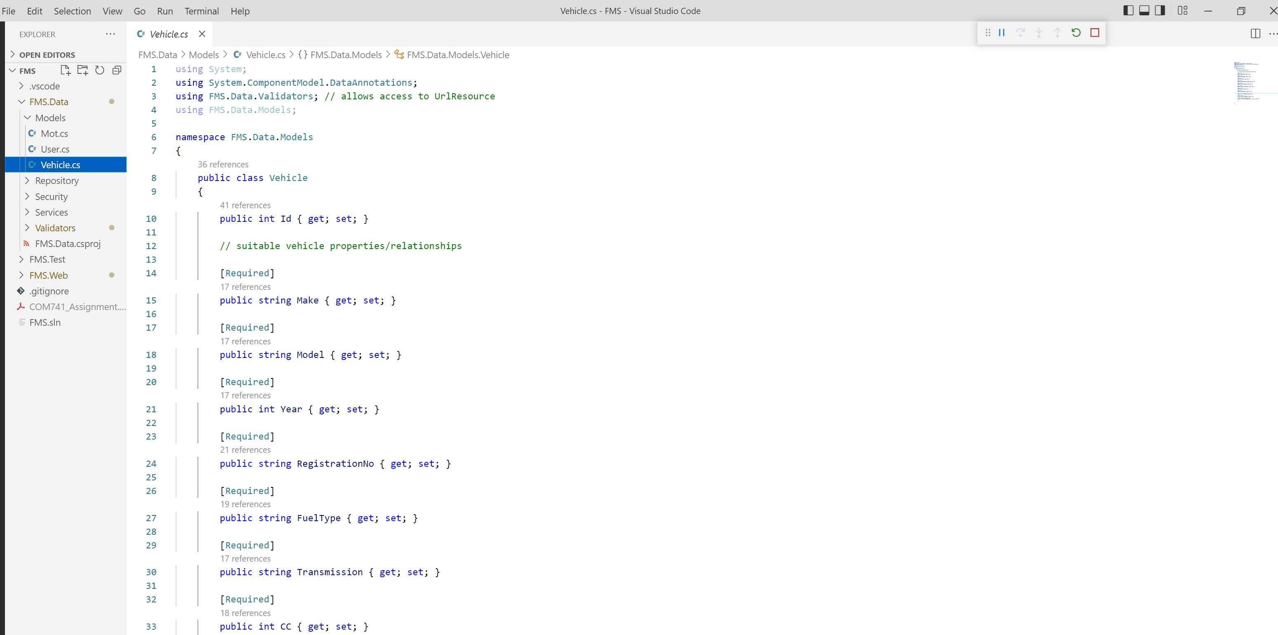

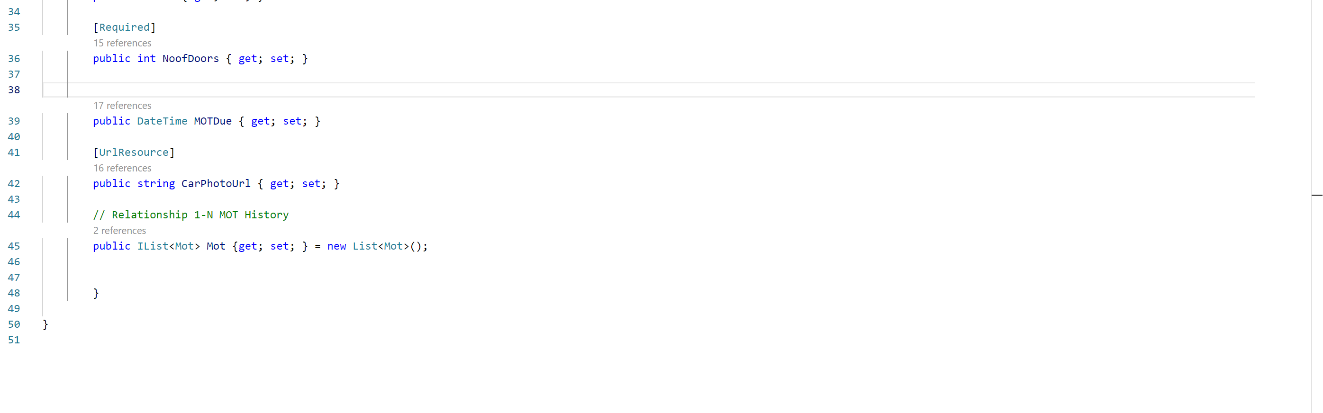

Mot Model:

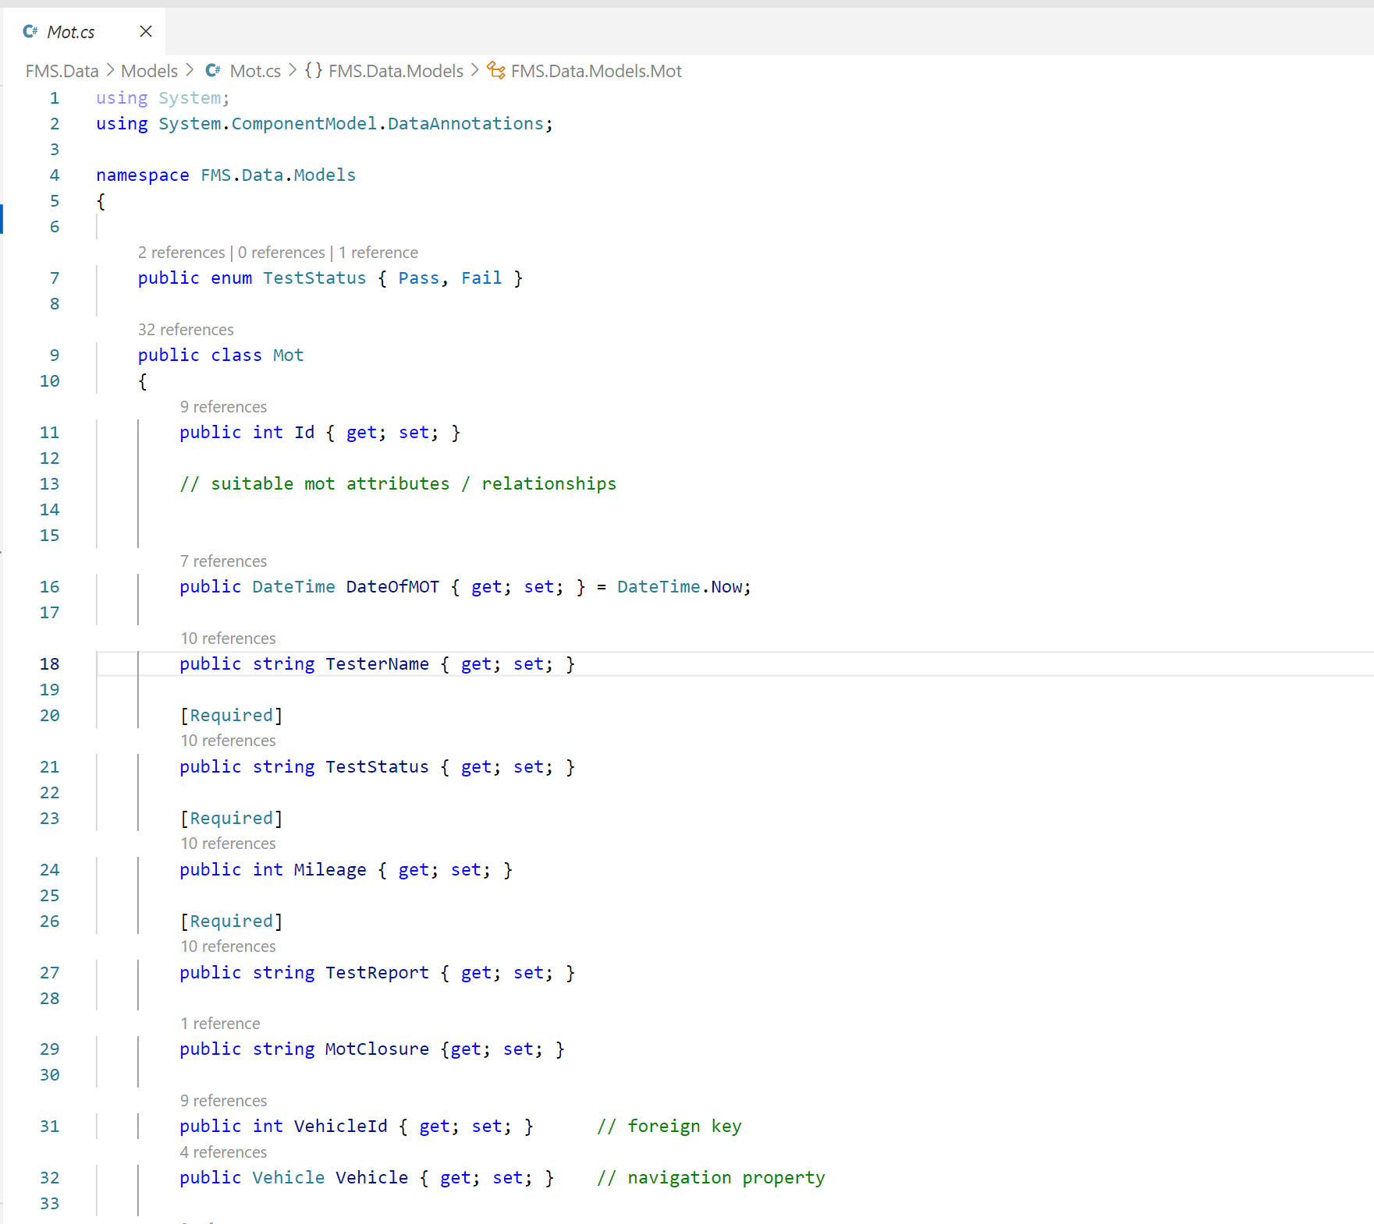

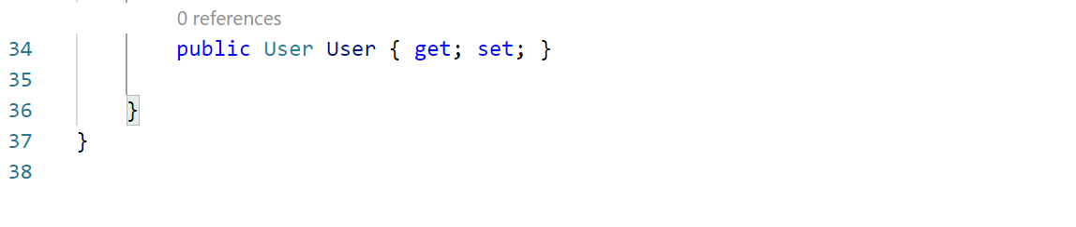

User Model:

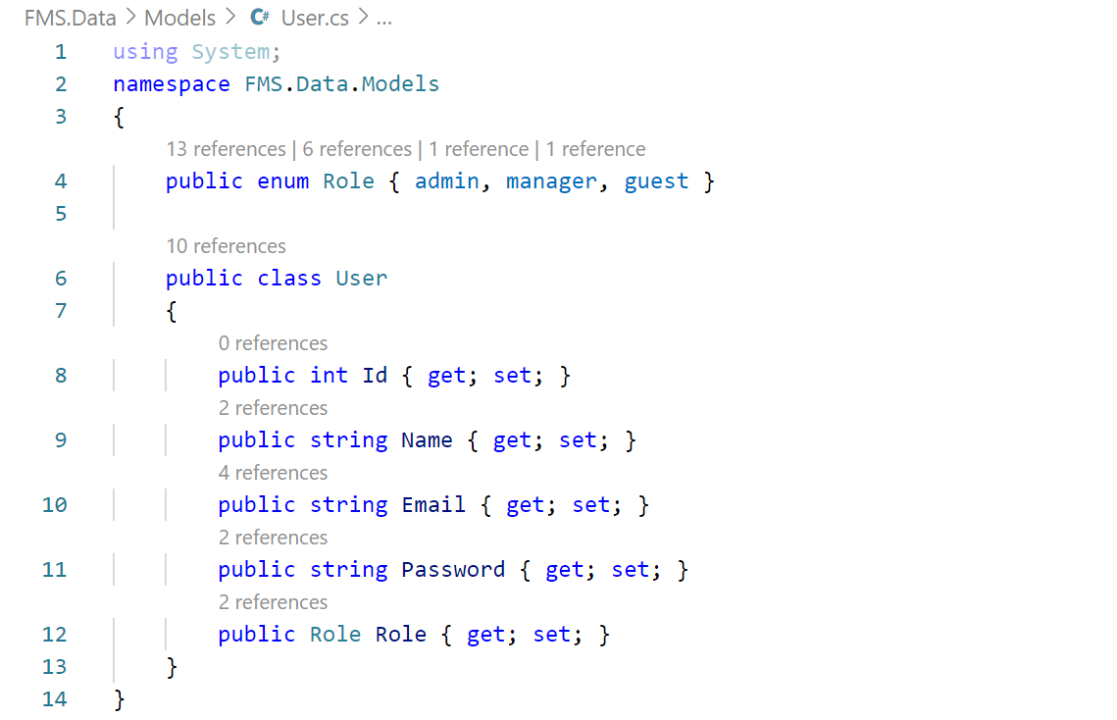

# View screenshots and codes

**User (Registration View)**

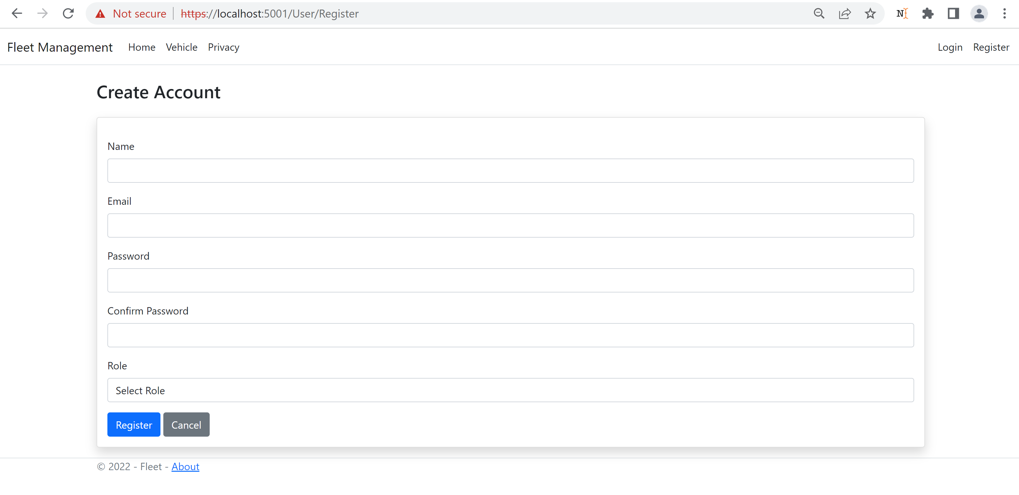

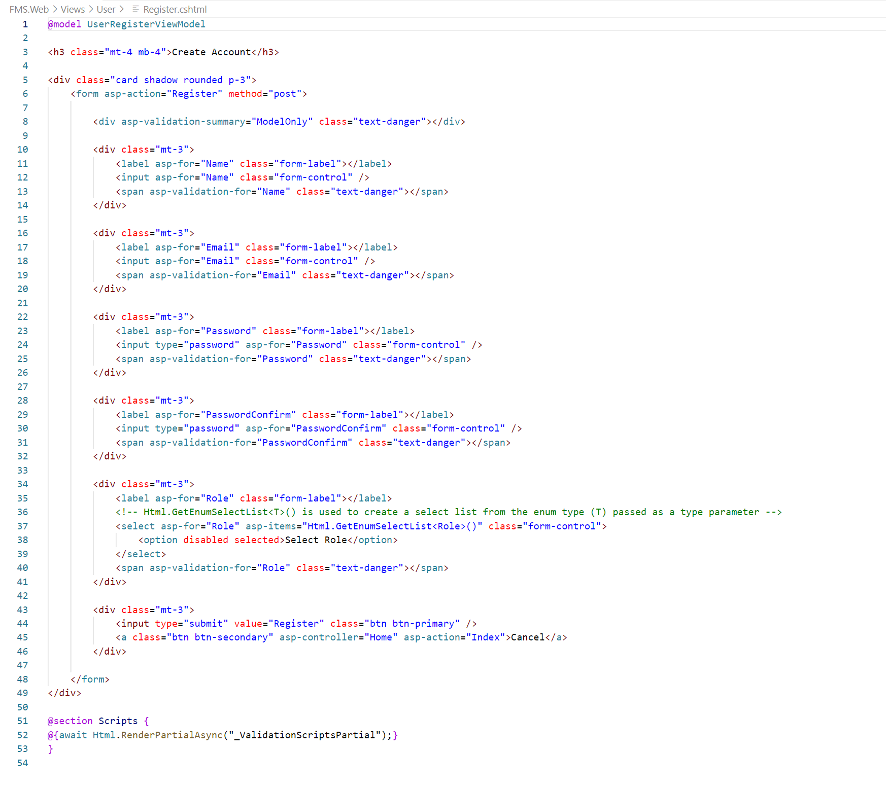

**User (Login View)**

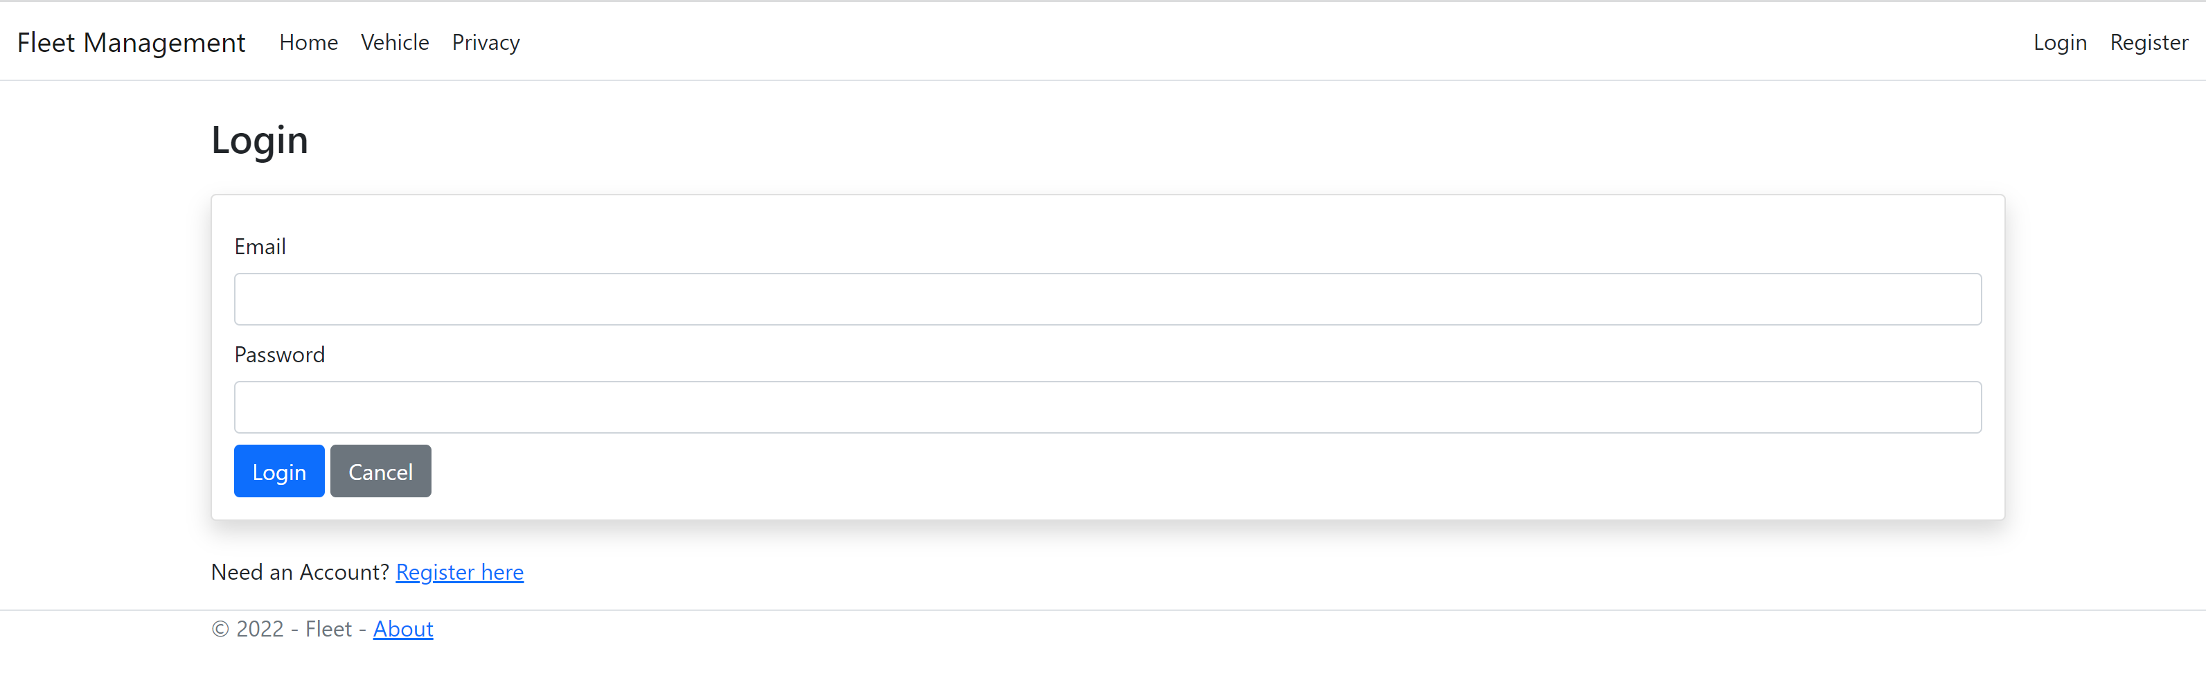

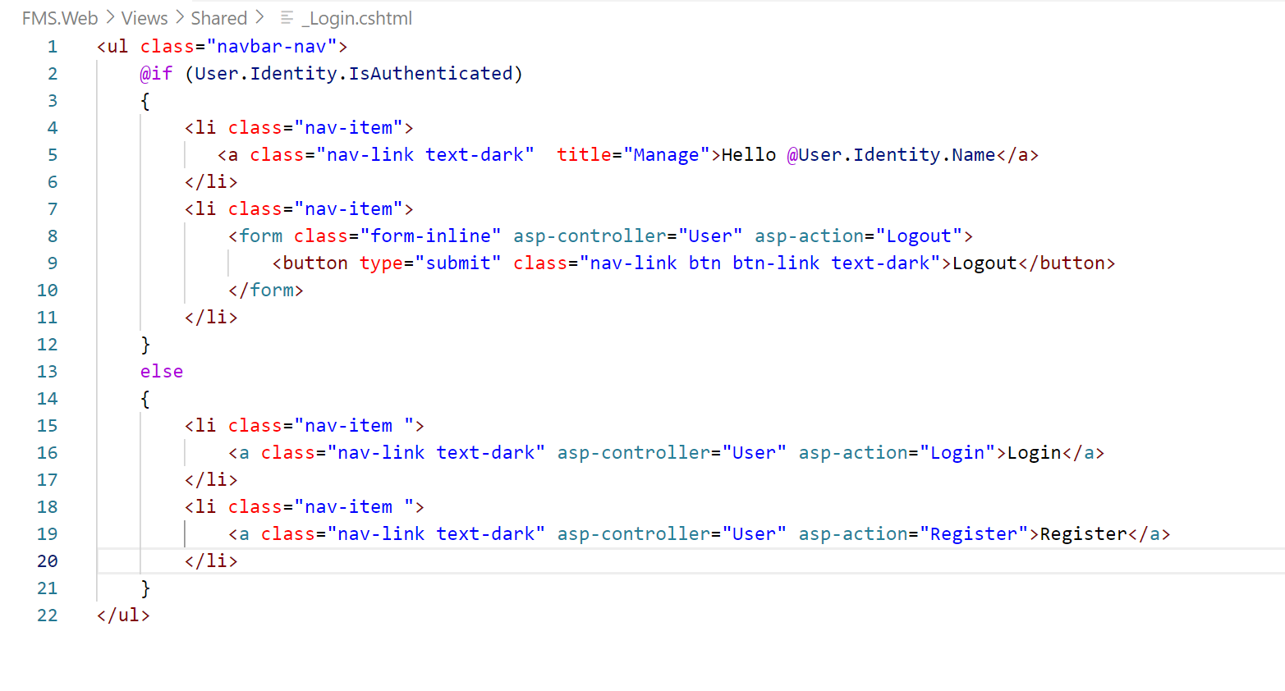

**Vehicle (Create view)**

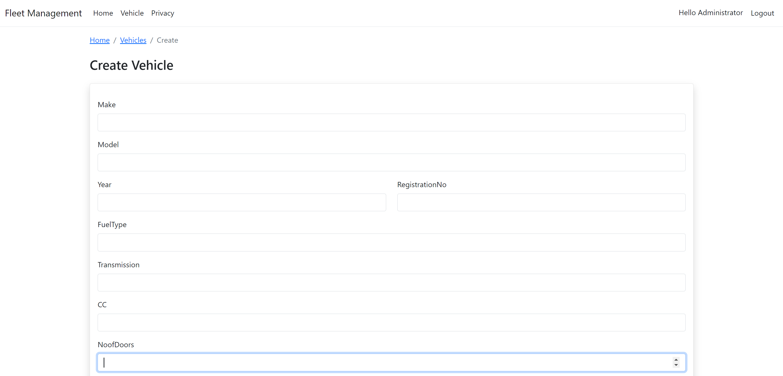

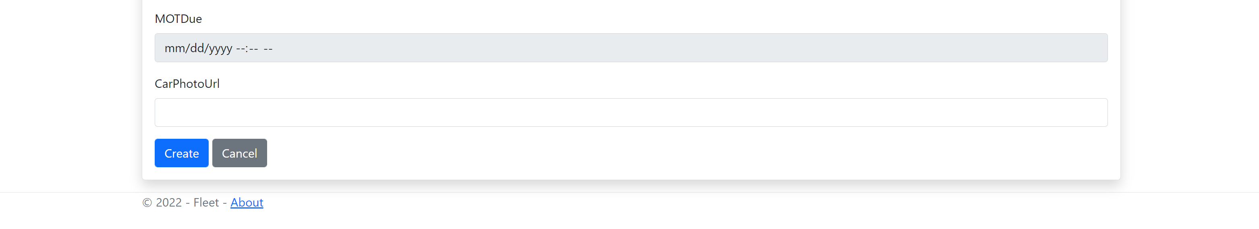

**Vehicle (Edit View)**

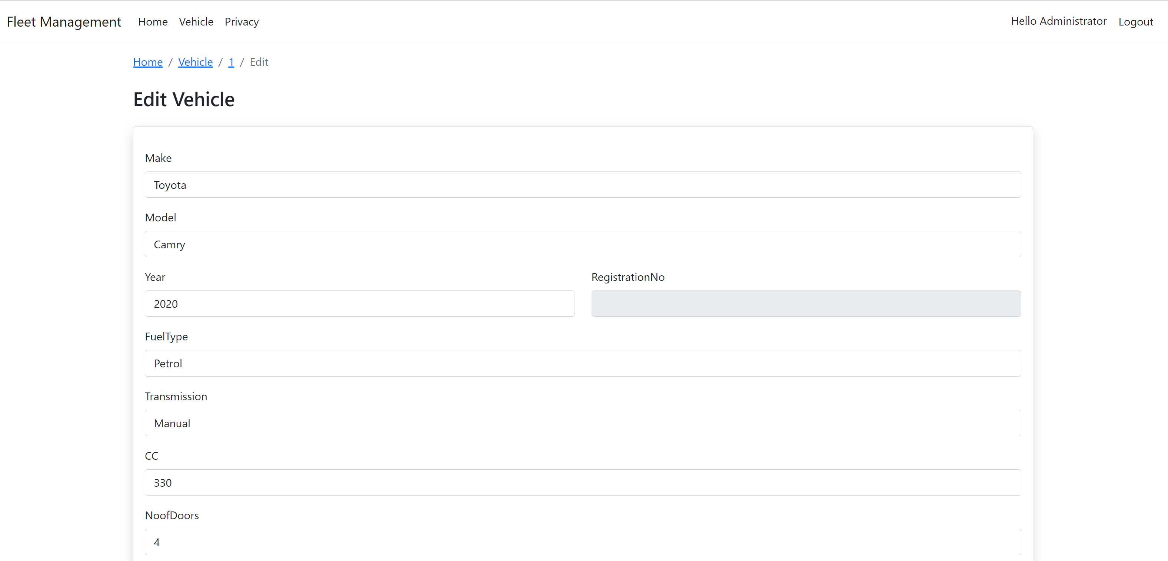

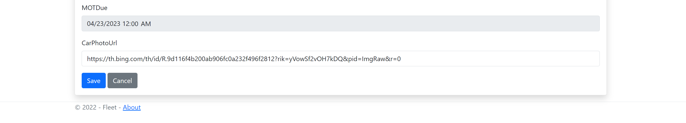

**Vehicle (Delete View)**

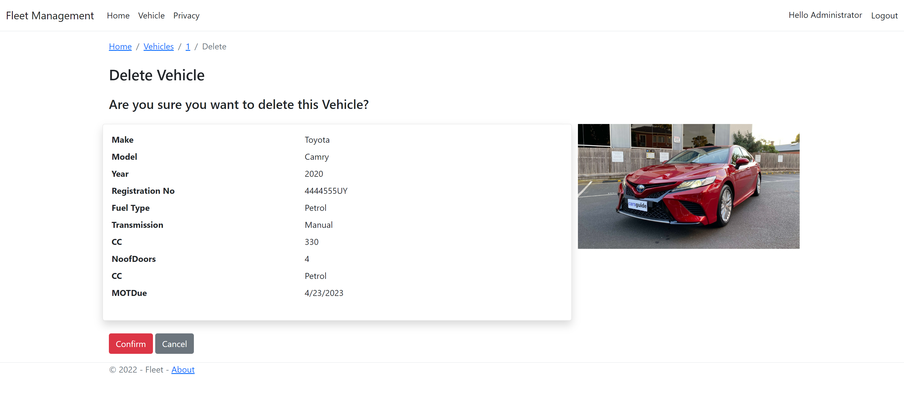

**Vehicle (Details View)**

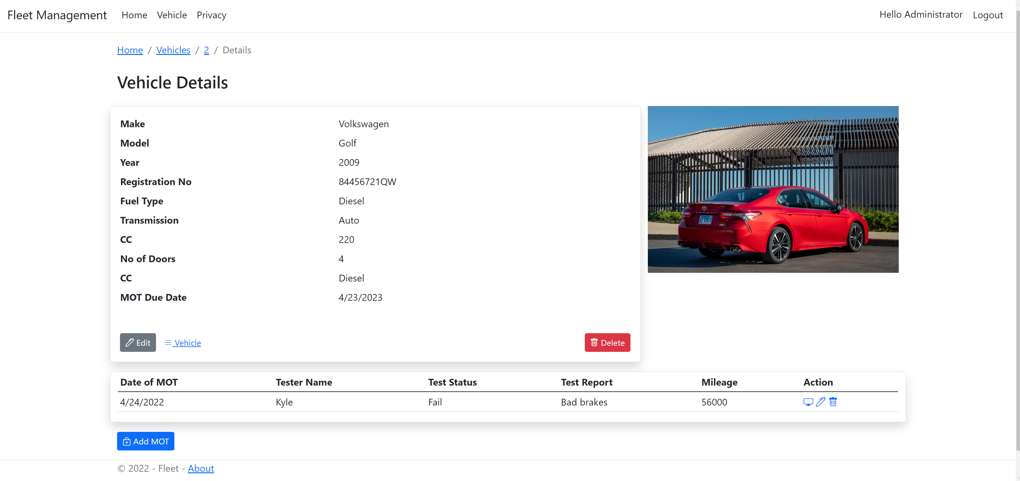

**Mot (Create View)**

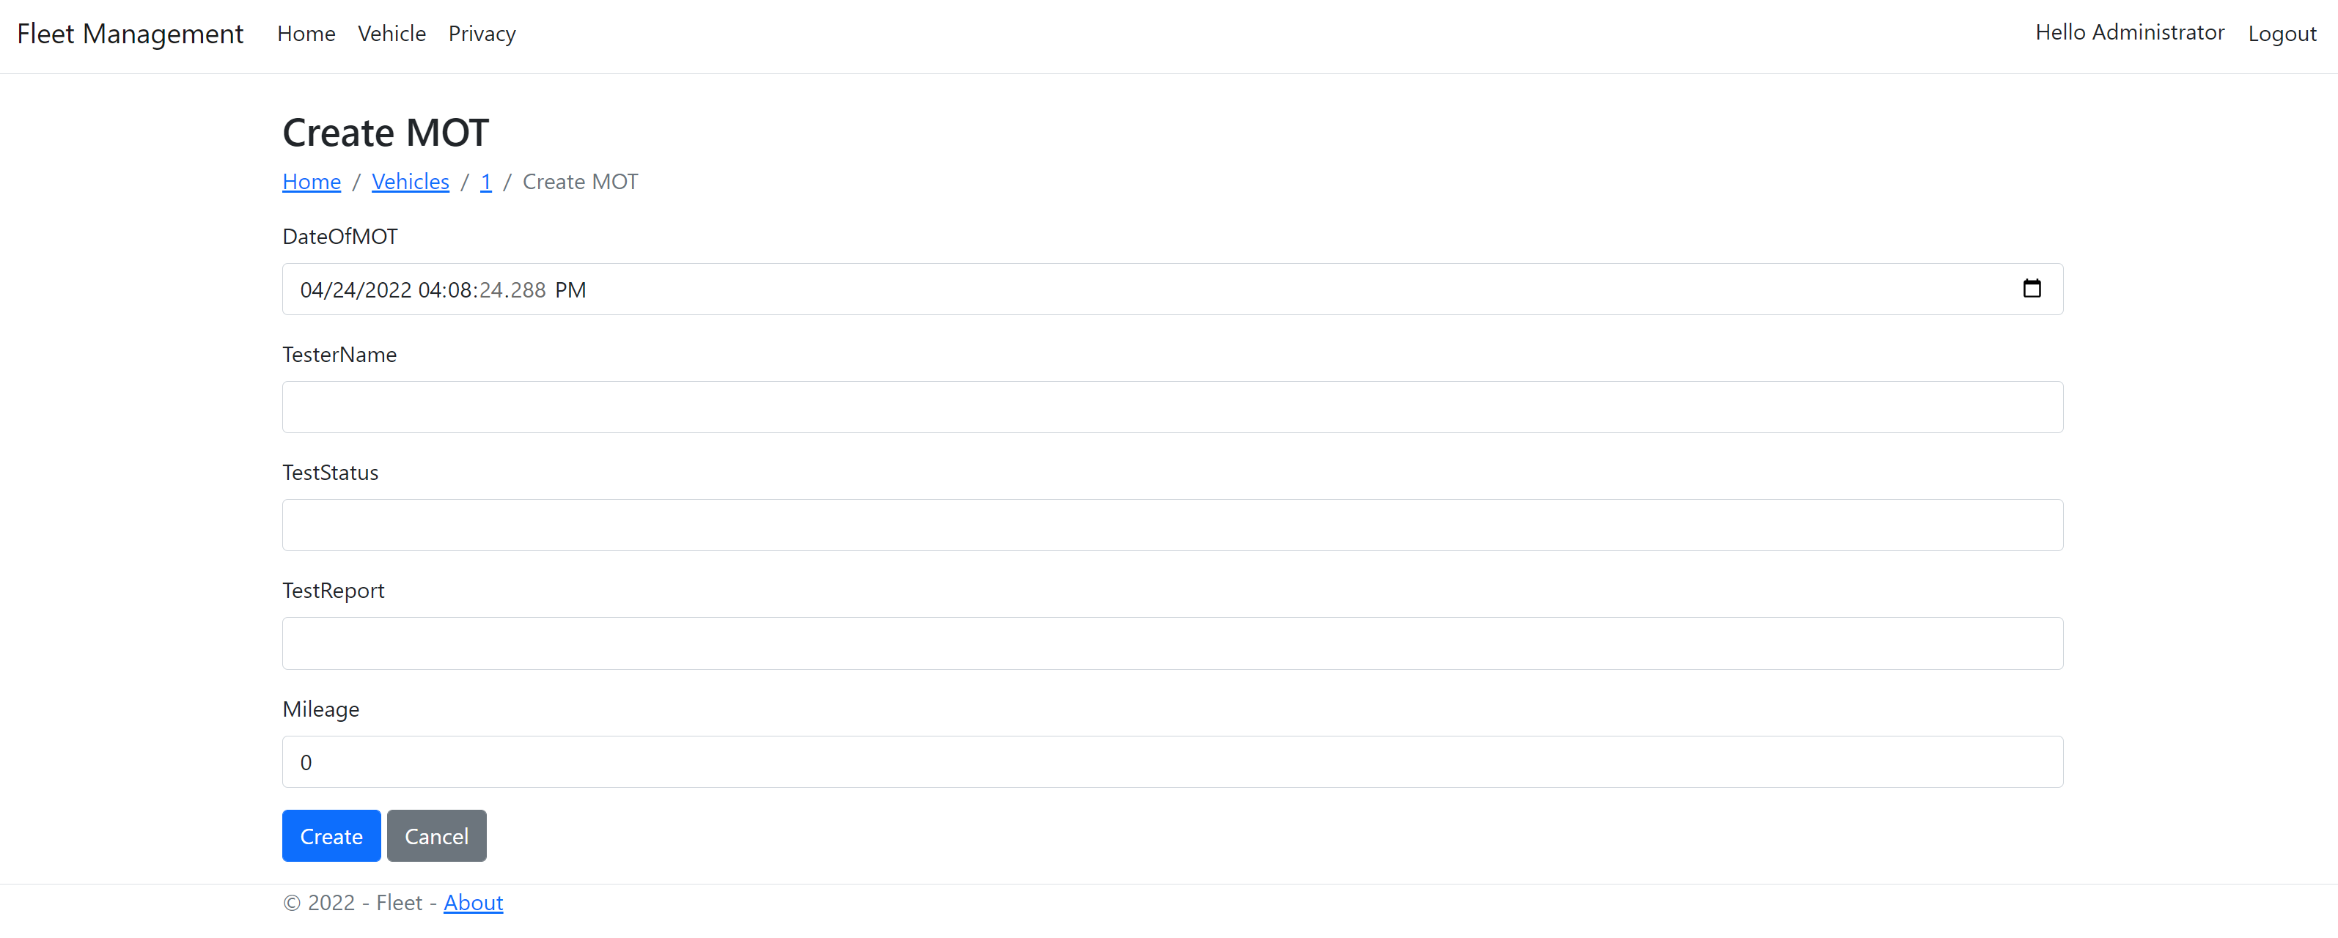

**MOT (Detail View)**

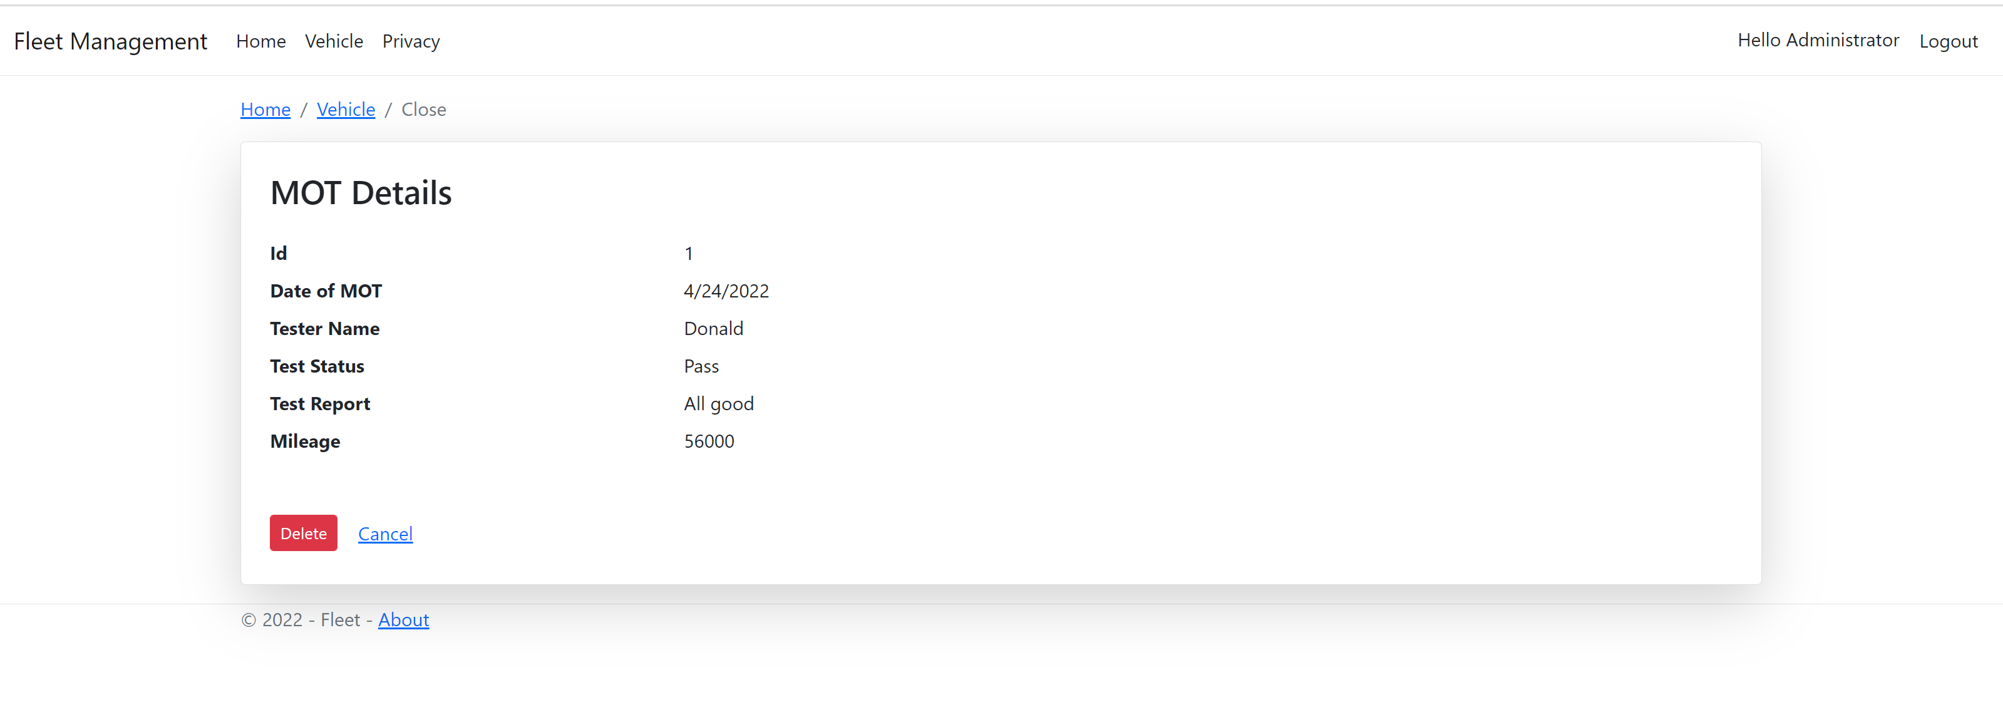

**Originality Declaration**

All CW submissions (electronic submissions of CW) should contain the following declaration

embedded in them.

I declare that this is all my own work and does not contain unreferenced material copied from

any other source. I have read the University’s policy on plagiarism and understand the

definition of plagiarism. If it is shown that material has been plagiarised, or I have otherwise

attempted to obtain an unfair advantage for myself or others, I understand that I may face

sanctions in accordance with the policies and procedures of the University. A mark of zero

may be awarded and the reason for that mark will be recorded on my file.

Student’s full name: Adedolapo Adetona

Registration number: B00855779

Date: 24/04/2022